

**Name : Eslam Abo Elkhair Borai Abd Elahmid**

**SEC : 8**

**ID : 177**

**TOPIC : Artificial Intelligence**

**Application Brief :**

**Because Artificial Intelligence, which is the behavior and certain characteristics of computer programs, that make them simulate human mental abilities and patterns of work. One of the most important of these characteristics is the ability to learn, infer and react to situations not programmed into the machine. However, this term is controversial because there is no definitive definition of intelligence.**

**Screen shots**

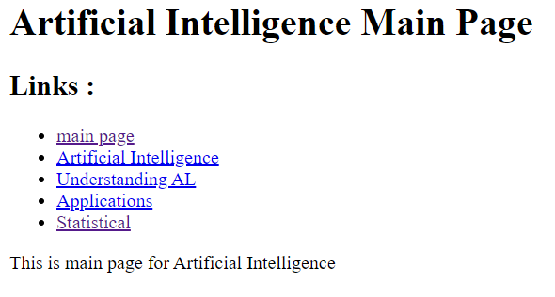

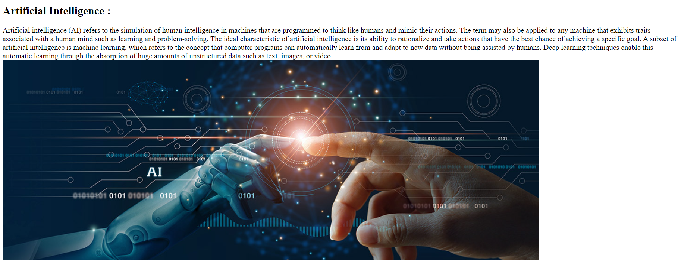

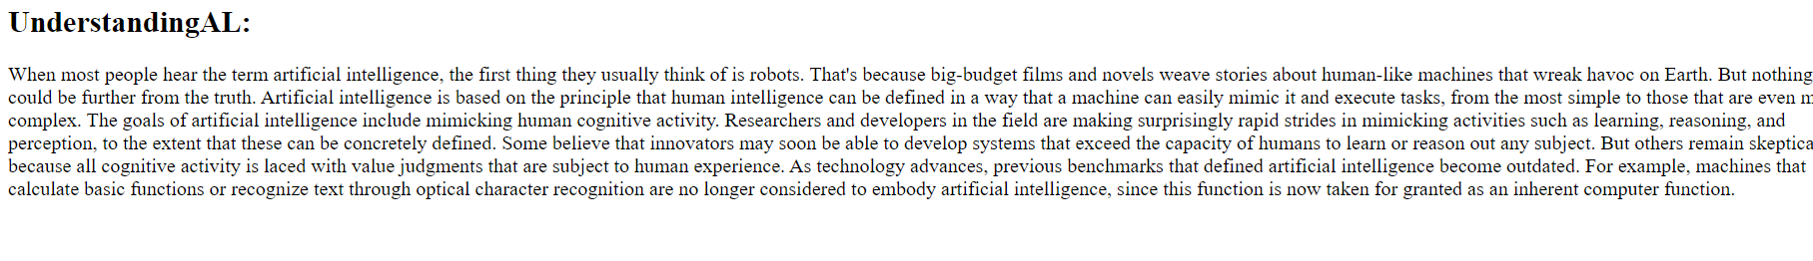

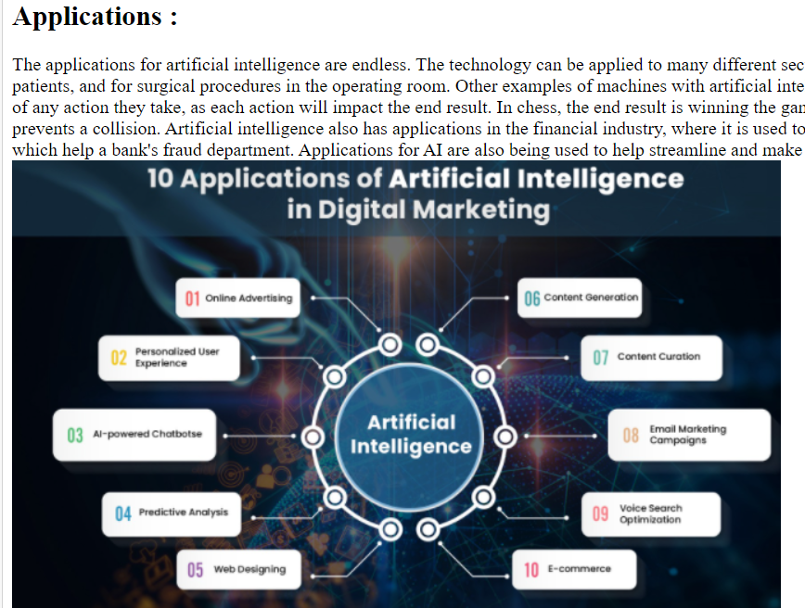

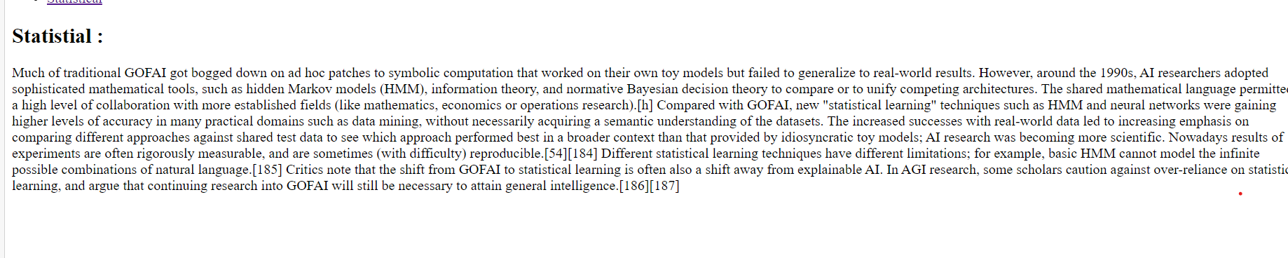

**Source code :**



